**Inheritance**

**What is inheritance?**

Inheritance is the ability for a class to use the methods and fields of another class directly.

**Benefit of Inheritance**

1. **Code reusability:** Inheritance allows a child class to use methods and fields from a parent class. This reduces the need to repeat code or rewrite them repeatedly.
2. **Maintainability:** with inheritance any changes made in the base class will automatically change wherever it is called in our code. This makes maintenance easier and more efficient
3. **Extensibility:** Inheritance allows you to extend the functionality of an existing class. Derived class can add new features or override existing methods to provide specialized behavior.

**Application of Inheritance**

The following code below has two classes: parent and child class. The child class has inherited methods and properties from the base class. We know this because of the full colon that is preceded by the Parent class name like so “ : Parent”.

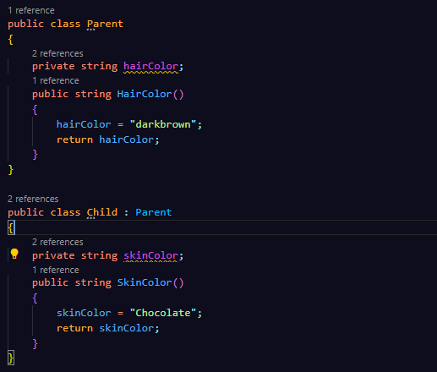

By creating an instance of the child class, we can use the HairColor() method in our code.

